 **Industrial Project Report**

**B-tech in Electrical Engineering**

**By,-----**

Bidyasagar Mallick – [11901621032]

Biswajit Roy – [ 11901621031]

Prosun Majumder – [ 11901621029]

Tapas Sarkar – [11901621038]

**Third-year student of**

**SILIGURI INSTITUTE OF TECHNOLOGY**

*THIS IS SUBMITTED IN FULFILLMENT OF THE REQUIREMENTS FOR THE DEGREE OF*

**AFFILIATED TO**

**Maulana Abul Kalam Azad University of Technology**

**Under the supervision of**

Mr. Ripam Kundu

**Sikharthy Infotech Pvt. Ltd.**

**MICROSOFT STOCK PRICE PREDECTION**

**Using Machine Learning**

**By……..**

Bidyasagar Mallick – [11901621032]

Biswajit Roy – [ 11901621031]

Prosun Majumder – [ 11901621029]

Tapas Sarkar – [11901621038]

UNDER THE GUIDANCE OF

**Mr. Ripam Kundu**

**Project Guide**

**Sikharthy Infotech Pvt. Ltd.**

*THIS IS SUBMITTED IN FULFILLMENT OF THE REQUIREMENTS FOR THE DEGREE OF*

**B.Tech**

IN

Electrical Engineering

**SILIGURI INSTITUTE OF TECHNOLOGY**

**AFFILIATED TO**

**Maulana Abul Kalam Azad University of Technology**

**Department of Electrical Engineering**

I hereby forward the documentation prepared under my supervision by **Ripam Kundu Sir** entitled **Siliguri Institute Of Technology** to be accepted as fulfillment of the requirement for the Degree of Bachelor of Technology in Electrical Engineering, **Siliguri Institute Of Technology** affiliated to **Maulana Abul Kalam Azad University of Technology** (**MAKAUT**).

**Mr.Ripam Kundu**

**(Software Developer)**

**Project Guide**

**Sikharthy Infotech Pvt. Ltd.**

**HOD**

**Department Of Electrical Engineering, SIT**

**Shilpi Ghosal**

**(Director)**

**Sikharthy Infotech Pvt. Ltd.**

**TPO**

**Siliguri Institute of Technology**

**Certificate of Approval**

The foregoing project is hereby approved as a creditable study for the B.Tech in Electrical Engineering presented in a manner of satisfactory to warrant its acceptance as a prerequisite to the degree for which it has been submitted. It is understood that by this approval the undersigned do not necessarily endorsed or approved any statement made, opinion expressed or conclusion therein but approve this project only for the purpose for which it is submitted.

Final Examination for

Evaluation of the Project

**Signatures of Examiners**

**ABSTRACT**

Windows 10 is one of the operating systems that so many people love about Microsoft. When Microsoft released Windows 10, it was announced that it would be the last version of windows and then Microsoft will only work on its updates. But now Microsoft has once again garnered a lot of attention from the world as the release of Windows 11 is just around the corner. So now will be a good time to predict Microsoft’s stock price as it is getting a lot of attention.

 we will implement Microsoft Stock Price Prediction with a Machine Learning technique. We will use Tensor Flow, an Open-Source Python Machine Learning Framework developed by Google. TensorFlow makes it easy to implement Time Series forecasting data. Since Stock Price Prediction is one of the Time Series Forecasting problems, we will build an end-to-end Microsoft Stock Price Prediction with a Machine learning technique.

**Group Member Signature**

**ACKNOWLEDGEMENT**

It is a great pleasure for me to acknowledge the assistance and participation of a large number of individuals in this attempt. Our project report has been structured under the valued suggestion, support, and guidance of **Mr. Ripam Kundu**. Under his guidance, we have accomplished the challenging task in a very short time.

Finally, we express our sincere thankfulness to our family members for inspiring me all throughout and always encouraging us.

**TABLE OF CONTENTS**

Chapter 1: Introduction

1: : Introduction

Chapter 2: What We Used

2.1: : Python

2.2: **Pandas**

**2.3: Numpy**

**2.4:** [**Matplotlib**](https://www.geeksforgeeks.org/matplotlib-tutorial/)/[**Seaborn**](https://www.geeksforgeeks.org/introduction-to-seaborn-python/)

**2.5: Tensorflow**

**INTRODUCTION**

The 42 analysts offering 12-month price forecasts for Microsoft Corp have a **median target of 280.00, with a high estimate of 328.70 and a low estimate of 212.00**. The median estimate represents a +15.34% increase from the last price of 242.76.

***:* WHAT WE USED :**

Python libraries make it very easy for us to handle the data and perform typical and complex tasks with a single line of code.

* **Pandas** – This library helps to load the data frame in a 2D array format and has multiple functions to perform analysis tasks in one go.
* **Numpy**– Numpy arrays are very fast and can perform large computations in a very short time.
* [**Matplotlib**](https://www.geeksforgeeks.org/matplotlib-tutorial/)/[**Seaborn**](https://www.geeksforgeeks.org/introduction-to-seaborn-python/)– This library is used to draw visualizations.
* Sklearn – This module contains multiple libraries having pre-implemented functions to perform tasks from data preprocessing to model development and evaluation.
* **Tensorflow** – TensorFlow is a Machine Learning Framework developed by Google Developers to make the implementation of machine learning algorithms a cakewalk.

**Scikit-learn-**

Scikit-learn is a free machine learning library for Python. It features various algorithms like support vector machine, random forests, and k-neighbours, and it also supports Python numerical and scientific libraries like NumPy and SciPy .

**Project Overview**

**Goal:**

We will be making a web application that predicts the maximum value of Microsoft Stock Price Predection at any given DateTime depending on real-time stock data.

The model will be made using Linear regression in Azure ML designer and trained on data from the yfinance API. The data will be downloaded locally and then uploaded onto Azure blob storage. Beforehand, we will write a trigger using Azure ML Python SDK that runs the training pipeline on every occurrence of data upload to blob storage. In this way, the model will always be trained on the latest MSFT stock data. The pipeline would be deployed via a real-time inference that provides an endpoint to get real-time predictions from the model. The entire process will be automated via a web application

Codes & Output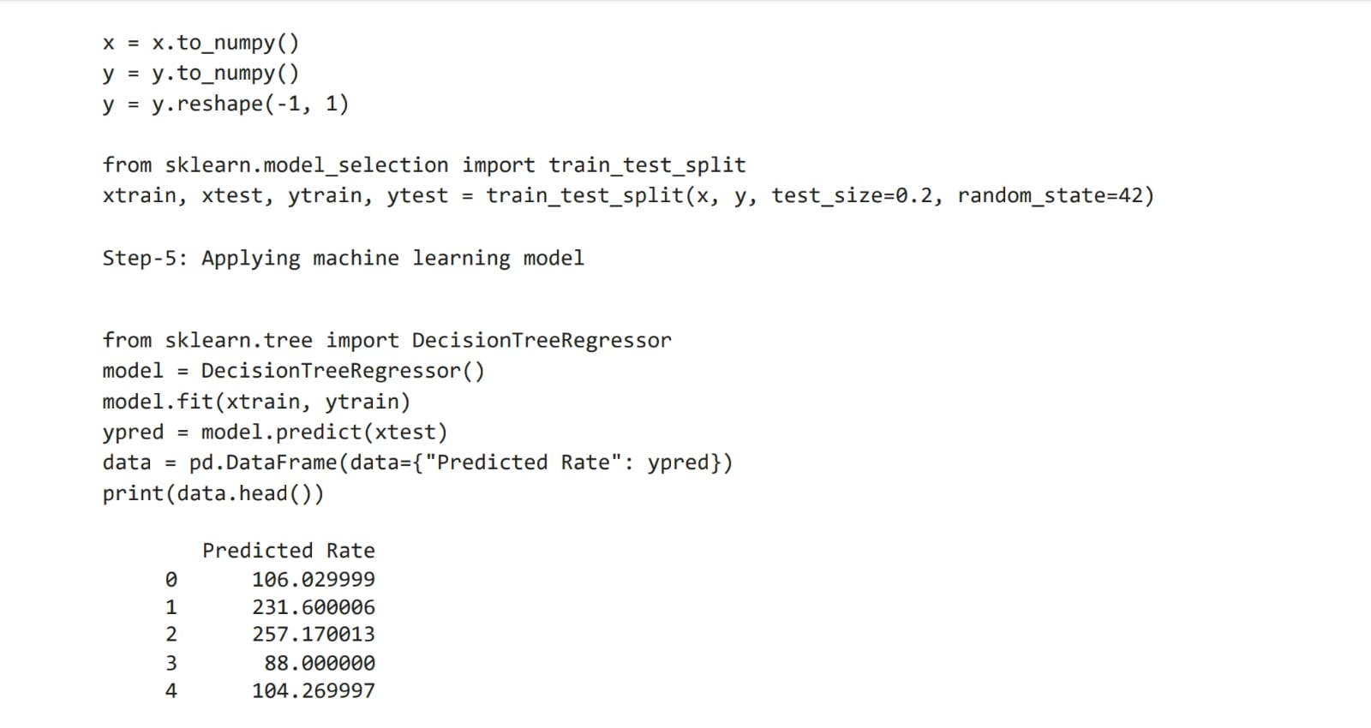

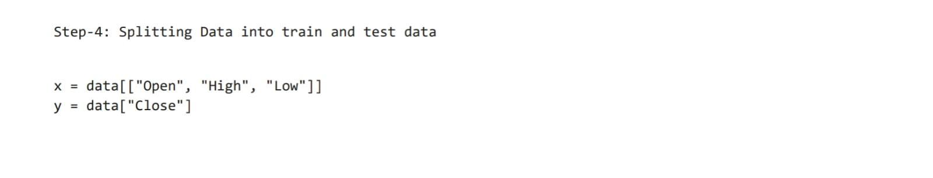

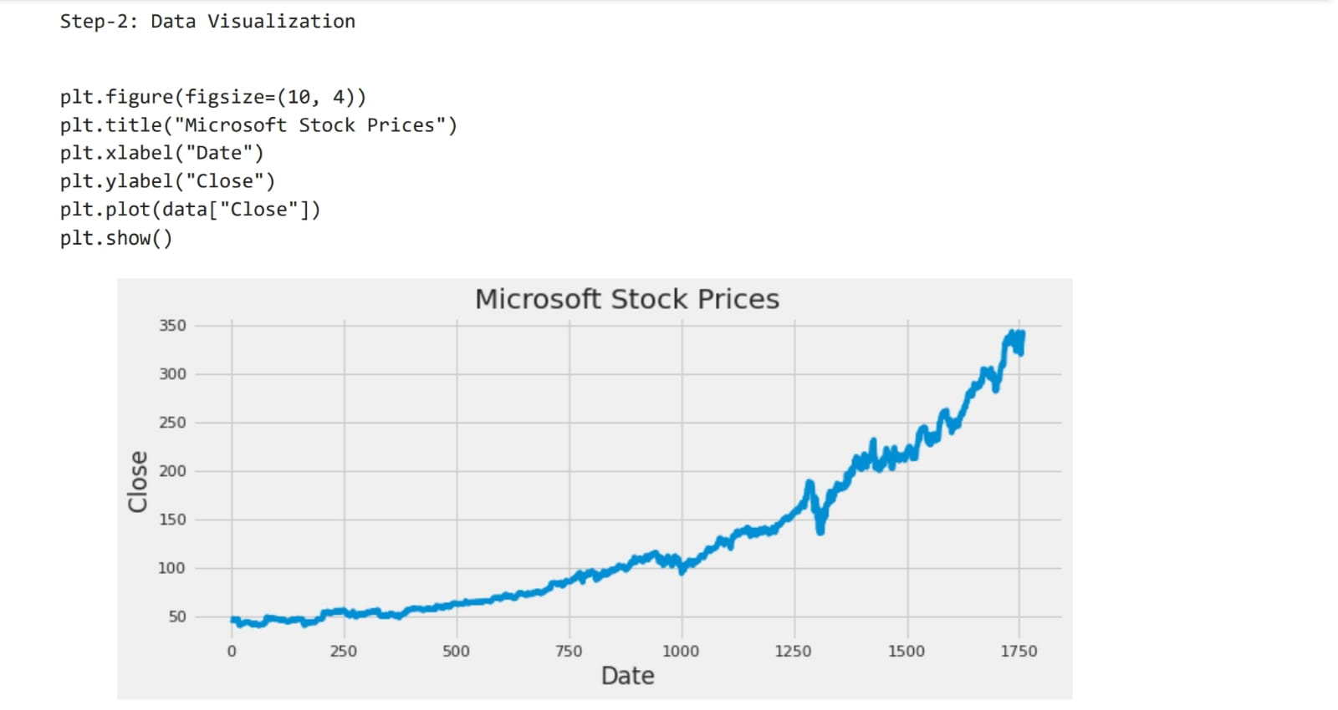

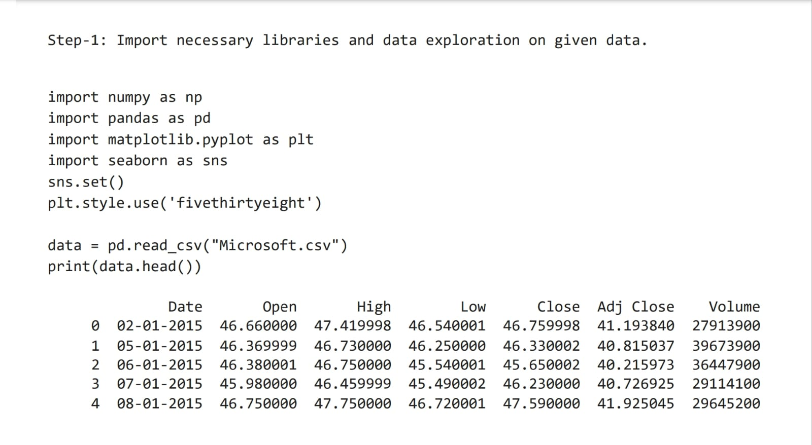

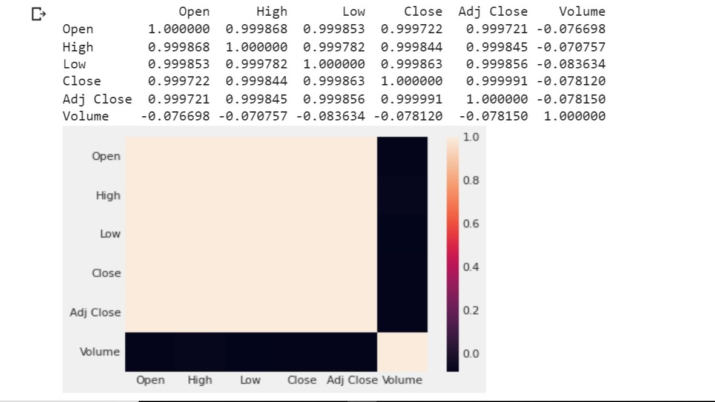**Contribution :**

Bidyasagar Mallick helped in Code

Biswajit Roy helped in documentation

Prosun Majunder helped in documentation

Tapas Sarkar helped in Making ppt

**Conclusion:-**

Time series forecasting is a very intriguing field to work with, as I have realized during my time writing these articles. There is a perception in the community that it’s a complex field, and while there is a grain of truth in there, it’s not so difficult once you get the hang of the basic techniques.

I am interested in finding out how LSTM works on a different kind of time series problem and encourage you to try it out on your own as well. If you have any questions, feel free to connect with me in the comments section below.

**Reference:-**

[**https://www.kaggle.com/code/paramarthasengupta/microsoft-stocks-price-prediction**](https://www.kaggle.com/code/paramarthasengupta/microsoft-stocks-price-prediction)

[**https://colab.research.google.com/#scrollTo=f9wcWO05gj6o**](https://colab.research.google.com/#scrollTo=f9wcWO05gj6o)

**https://www.geeksforgeeks.org/**